1. **Find scientific articles proving or refuting the following statements.**

* Flu shots have / have no side effects
* Usefulness / not usefulness of drinking coffee

1. **Analyze this flu vaccine for side effects.**

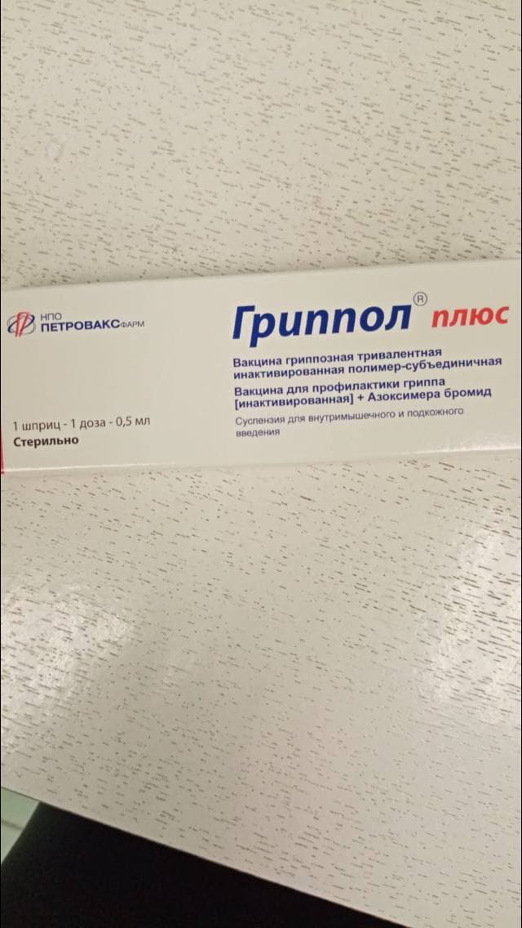

1. **Find articles that have analytics of the same symptoms described below.**

When I am in a stressful situation, I'm being able to sleep 1-4 hours a day.

but not calmly, I always see tense dreams, and when I suddenly get up, sometimes I notice that either my fingers are tight / clenched, or the whole side (leg, hand)

and I also feel compression on the left back side of my head, and sometimes different pains (either sharp, as if they would splinter, or dull pain)

even when I strain a little, then on the left side of the shoulders (under the shovel) I feel heartburn and also compression

and when there is a lot of stress, my hands starting to shake, and if there is more, then panic.

about sleep, sometimes I sleep 1-2 hours, and sometimes 12.

for example, sometimes I'be being able to sleep only from 7 AM, but then I don't want to get up at 3 PM

but I get up, because:

1. The sleep pattern will become worse, and a harm to health is being more

2. I need to work

3. The quality of life will get worse